Training Report

A report submitted in partial fulfillment of the requirements for the award of degree of

Bachelor of Technology In

Computer Science and Engineering Submitted by: Bazgha Razi



Delhi Global Institute of Technology Bahadurgarh, Jhajjar, Haryana 124201 Affiliated to

Maharshi Dayanand University

**Date: 07/09/2022**

**To, Ms. Bazgha Razi**

**TO WHOM SO EVER IT MAY CONCERN**

This is to certify that Bazgha Razi, has successfully completed her internship at **DHIRATI EDUCATION (Run & Managed by FMS/IIT/IIM Alumni)**, as a Web Development Executive from 15th July 2022 to 1st September 2022.

During this project, we found Bazgha Razi sincere and hard working.

We wish her all the best for all her future endeavours.

Authorised Signatory

For **Dhirati Education (Run & Managed by FMS/IIT/IIM Alumni)**

**Pratyush Angirish (SENIOR MANAGER)**

Flat no. 22 2nd Floor Metro gate No. 1, Tilak Nagar New Delhi 110018 Phone

– 828-747-7876 011- 41077760 ([www.dhiratieducation.com)](http://www.dhiratieducation.com/) Other Branches- PitamPura, Paschim Vihar, Dwarka

Other States- Jaipur, Jhansi, Gwalior, Lucknow

## ACKNOWLEDGEMENT

It has been great honour and privilege to undergo training at Dhirati Education.

I have taken efforts in this project. However, it would not have been possible without the kind support and help of many individuals. I would like to extend my sincere thanks to all.

I am highly indebted to Mr. Pratyush Angirish and Mr. Sandeep for their guidance and constant supervision as well as for providing necessary information regarding the project and for their support in completing the project. Their constant guidance made us understand this project and its manifestations in great depths helped us to complete the assigned tasks on time.

I am thankful and grateful to Saurav Bamotra who helped me in this project. He constantly guides me during this internship period. He helped me by told some of my mistakes and give some ideas to handle my mistakes and improve my project more better.

Bazgha Razi B.Tech(CSE)

## DECLARATION

I here by declare that the project report entitled “Dhirati Education’s App” submitted by me to Dhirati Education. Bazgha Razi partially fulfilment the requirements for this project work under the guidance of Mr. Pratyush Angirish and Mr. Sandeep.

I also declare that, the report is only prepared for my academic requirement not for any other purpose. It might not be used with the interest of opposite party of Dhirati Education.

Bazgha Razi B.Tech(CSE)

## CONTENTS

CERTIFICATE 2

ACKNOWLEDGEMENT 3

DECLARATION 4

1. INTRODUCTION
   1. Introduction 7
2. COMPANY PROFILE
   1. Details of the company 9
   2. Company Logo and Image Gallery 10
   3. Company Vision and Mission 11
   4. Dhirati Education 11
   5. History of Dhirati Education 12
   6. Why Dhirati Education? 14
   7. Features of Dhirati Education 15
   8. SWOT Analysis of Dhirati Education 16
   9. Career in Dhirati Education 17
   10. Success Stories 18
3. PROJECT DETAILS
   1. Web Portal of Dhirati Education 20
   2. Android App of Dhirati Education 20
4. FEASIBILITY STUDY
   1. Introduction 21
   2. Summary 22
   3. Types of Feasible Study 22
5. WEEKLY TIME MANAGEMENT
   1. Weekly work for project 24
6. TECHNOLOGY USED
   1. Project Requirements 25
   2. What is an IDE? 26
   3. JavaScript 27
   4. Uses of JavaScript 28
   5. Facts about JavaScript 29
   6. Node.js 30
   7. How to Install Node.js 32
   8. MongoDb 33
   9. Robo3T 34
   10. DART programming language 35
   11. Flutter 36
   12. Firebase for Flutter 40
7. TESTING & IMPLEMENTATION
   1. Testing 42
   2. Implementation of Web Portal 47
   3. Implementation of Dhirati Education’s App 49
8. LEARNING’S AND VALUE ADDITIONS
   1. Learning’s and value additions 56
   2. Theoretical v/s Practical Knowledge 57
9. CONCLUSION
   1. Conclusion 59
10. REFERENCES
    1. References 60

INTRODUCTION

As a web development intern, I was in charge of project including web portal of Dhirati Education. In this I have to design a web portal for Dhirati Education according to their guidance.

This internship has been a great learning experience as I have discovered most of the tools and techniques during this internship. Learned about various frameworks and also learned about programming language for making Dhirati Education’s App and Dhirati’s Education Web Portal.

Prior to internship, I’ve already experience working with Javascript. It is a text-based programming language used both on the client-side and server-side that allows you to make web pages interactive. Where HTML and CSS are languages that give structure and style to web pages, JavaScript gives web pages interactive elements that engage a user. It is also used in making web portal.

During the internship period, I used Javascript and EJS for simple templating language that lets me generate HTML markup plain Javascript. I define HTML pages in EJS syntac and specify where various data will go in the page. Then, it combines data with the template and renders a complete HTML page where EJS takes your data and inserts it into the web page according to me that I have defined the template.

I also used Node.js for backend development. It is a framework for writing server-side JavaScript applications. Work with npm library also. It has packages that I used in my project to make my development faster and efficient.

Also learned about databases and worked on MongoDB. MongoDB is a document database used to build highly available and scalable internet applications. With its flexible schema approach, it's popular with development teams using agile methodologies. I used this for storing data for access data easily.

I was given the role as a web developer, but after completion of web portal I received an opportunity for app developer intern and then I started working on app development.

During app development period I had also learned about flutter. It is an open-source framework by Google for building beautiful, natively compiled, multi-platform applications from a single codebase. Flutter used Dart programming languages. So, I also learned about this programming languages. I also used flutter packages during the development period.

Also work with canva, figma and wireframes for designing the web portal and app.

I have also met number of people with different background during the virtual meetups. They are passionate about technology and innovation. They made this journey truly inspiring from a technological point.

## COMPANY PROFILE

### Name of the Company

Dhirati Education

### Website of the Company

<http://www.dhiratieducation.com/>

### Address of the Company

Flat no. 22 2nd Floor Metro gate No. 1, Tilak Nagar New Delhi 110018 Other Branches- PitamPura, Paschim Vihar, Dwarka

Other States- Jaipur, Jhansi, Gwalior, Lucknow

**E-mail Id of the Company** [support@dhiratieducaion.com](mailto:support@dhiratieducaion.com) [info@dhiratieducation.com](mailto:info@dhiratieducation.com) [admissions@dhiratieducation.com](mailto:admissions@dhiratieducation.com)

### Phone No. of the Company

+ 91 11410 77760

+ 91 82874 77876

### Company Logo and Image Gallery



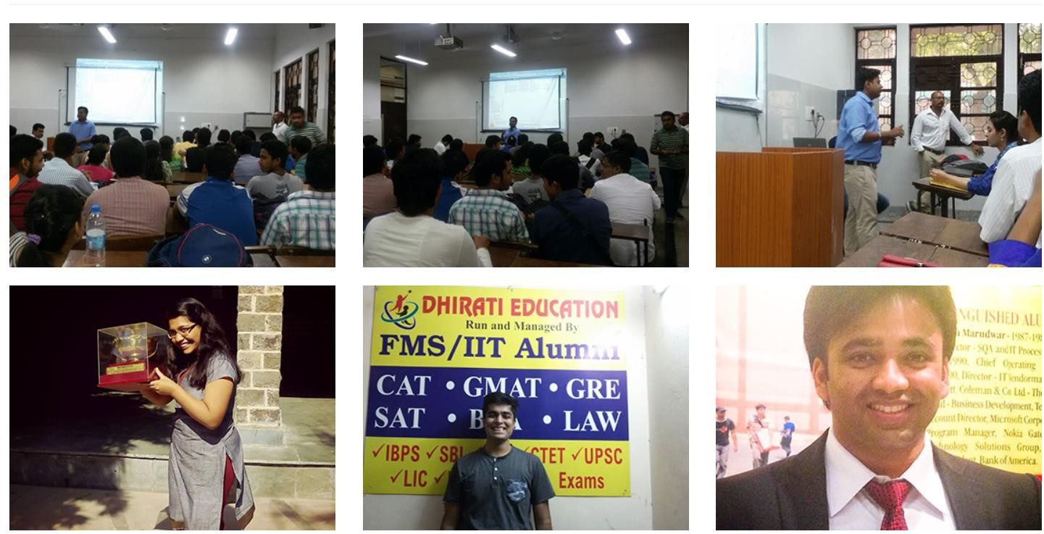

**COMPANY VISION AND MISSION**

**Vision:** To become the best education provider in test preparation industry to fulfill the dreams of every aspirantfor shaping her/his future.

**Mission:** To continuously provide affordable education to every section of society. To be with every aspirant always to help them making right decisions in her/his career paths by following our core values- Honesty, Dedication and Hard Work.

**DHIRATI EDUCATION**

Dhirati Education is founded by some brilliant and visionary minds (Alumnus of IIM/FMS/IIT)of our country with a composite experience of 80+ years in training students for various management entrance examinations. Everyone in the team is a passionate trainer.

So far,more than 10000 of our alumni have passed out from top colleges across globe and working in the best firms like MNCs,PSUs, Banks and Central Government division .We wish to form a society where students can get value for their money and not only a degree.

The team has also serviced its expertise to more than 50 degree (Engineering+ MBA) colleges in India and abroad. Dhirati Education is present in Middle East and is catering to test preparation for GMAT, GRE, IELTS, TOEFL and SAT.

# History of Dhirati Education

Dhirati Education is founded by some brilliant and visionary minds (Alumnus of IIM/FMS/IIT)of our country with a composite experience of 80+ years in training students for various management entrance examinations. Everyone in the team is a passionate trainer. So far,more than 10000 of our alumni have passed out from top colleges across globe and working in the best firms like MNCs,PSUs, Banks and Central Government division .We wish to form a society where students can get value for their money and not only a degree. The team has also serviced its expertise to more than 50 degree (Engineering+ MBA) colleges in India and abroad. Dhirati Education is present in Middle East and is catering to test preparation for GMAT, GRE, IELTS, TOEFL and SAT.

They successfully counselled more than 15,000 students through Career Workshops and Seminars in last 20 years. Our dedication and hard work has helped several students to achieve their dreams. Our up -to-date knowledge about all Career streams, makes us conversant with all types of Careers. Our team has addressed seminars in various Colleges and schools in Mumbai, Pune, Dehradun, Nainital area, Dubai, Sharjah and MP. Our team members have been panelists in numerous academic competitions in schools like Scindia School, GGHS, IPS School etc. We are in research and development of making proper mock tests for various competitive exams with analytics to help the students for getting better scores.

The team behind Dhirati Education has been engaged in providing counseling to Indian students aspiring to get better jobs with better perks. Till date we have helped more than 1500 students from various Indian Schools like IIT Kharagpur, IIT Mumbai, IIT Delhi, NSIT Delhi, DCE Delhi, IIT Roorkee, NIT Surathkal, IIT BHU, NIT Jalanadhar, SGSITS Indore, VIT, LSR New Delhi, IIITM Gwalior, IRIMEE (SCRA) etc. We have always gone an extra mile to help our students get that extra boost and push as a result, the majority of our students get selected in various Government sectors.

* Mr. Uttam Kumar Sharma-CEO and Founder (MBA-FMS,Delhi)- Experience- 11 years.
* Mr. ShahiKalam-Co-Founder (B.Tech+ MBA-IMT)-Experience-8 years.
* Mr. A.K.Vishwakarma- MBA (Boston University,USA)-18 years’ experience.
* Mr. H. P Goel- Head-Academic Curriculum- IIM-Calcutta- Experience-35 years.
* Mr. Divakar Sankhla-Head-GD & PI- IIT, Madras+ IIM Lucknow- Experience-8 years.
* Mr. Sanjay Agarwal-LLB/LLM- Author of LLM Entrance Examination for

D.U under Singhal Publications.

* Shubhadeep Roy- IIT Kharagpur+IIM Calcutta.

### The four strongest Pillars of “Dhirati Education”

* Concept Building: Theory based classroom training for concept clearance and topic wise study.
* Skill Development: "MORE STUDY MORE DOUBTS". Advance level learning for concept application and doubt clearance.
* Student Analytics & Reporting: Application of concept through regular test series for the mental readiness of Exam.
* Confidence Building: "SPEED WITH ACCURACY IS SUCCESS" Time Bound efficiency supported by the high level of analytics, to score better in exams.

# Why Dhirati Education?

### 360 Degree Approach

“360 DEGREE APPROACH”: Dhirati Education has uniquely designed peer to peer marking and mentoring of students.

### Advance Materials

Modernized “ADVANCE MATERIALS”- Our study material is well researched and developed by best experts of the industry.

### Success Method

Innovative “Success Method” – Unique pedagogy of Dhirati Education: Learning is not memorizing, but executing accurately.

### Dhirati Education Classroom

Digitalized format of classrooms equipped with better analytics for better learning and best results.

# Features of Dhirati Education

#### Spectacular Results

Years of impeccable success and glory. We make you the best using the best resources, for what we sow, so we reap. The better inputs we give, the better output you become.

#### Materialized Resources

Complete study package along with digitalized classrooms Our faculty equipped with the best resources blended with the best technology makes us unparalleled in the market.

#### Excellent Faculty

Teacher who have their resume filled with 20 years of educational experience. When you have a great painter, a masterpiece painting is made, when you have a great teacher, a successful career is made.

#### Better Analytics

When technology meets hard work, the result is fabulous. In depth analysis of students, highlighting their strong and weak points which helps them out in the best possible way towards their next level of learning.

**SWOT Analysis**

SWOT stands for Strengths, Weakness, Opportunities, and Threats. Based on the dynamics of our group and our goals, a SWOT analysis will allow us to focus on areas that can help us maximize our strengths, remove our weaknesses, leverage on opportunities, and address threats.

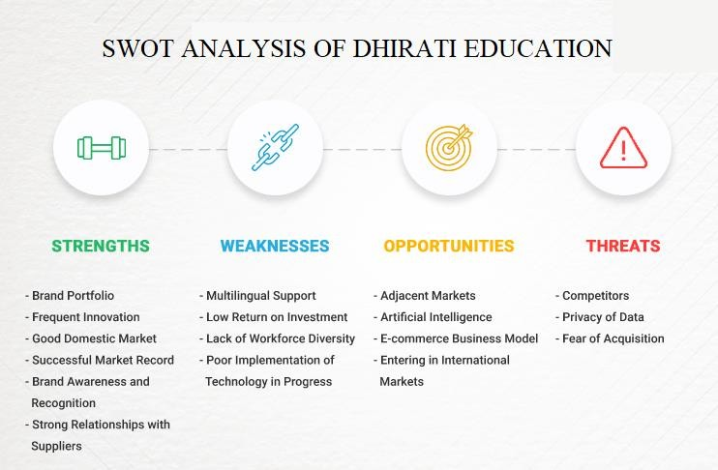

CAREER IN DHIRATI EDUCATION

You can apply as a mentor in Dhirati Education

### Become a Mentor, Become a Future Shaper

We believe in "Better Education For a Better World"

Great individuals are the backbone of any organization. In Dhirati Education it is our vision to unite the best individuals and give them the best conditions to groom themselves and perform to their optimum caliber. Your dreams shall be fulfilled by a longing to make a commitment to Education Sector and to launch your dreams, we will give you the stage.

We understand the need of "Motivated Mentors and Enthusiast Teachers" who can walk that extra mile and plant those seeds of wisdom deep within you, that it grows within you and bears fruits of success.

We're looking out for individuals with intensity so intense it converts ordinary beings into - masterminds, visionaries and pioneers who can place thoughts into movement. Whip-savvy, exceptionally energetic people have been the drivers behind Dhirati Education since it's inception. So come, join and let's share a trip of taking Dhirati Education to bewildering statures and roaring success.

# Success Stories of Dhirati Education









## PROJECT DETAILS

### Introduction

Web Portal Of Dhirati Education

It is specially designed website that brings all the information of Dhirati Education. It contains About Section, Courses Section, Contact Information.

Also created test portal for daily student user for that we have to first create Login Section.

So, in Login Section, only those can login which had their username and password issued by Dhirati Education so for that I have to save the data of the user. So for saving the data of the user I had used database. I had use Mongodb for adding my database.

After login, web page opens and, in that student, get their assignment, some important announcements and all the important content for their preparation. Content was in the form of video as well as in written format.

Android App of Dhirati Education

Android app is made for Dhirati Education using Flutter. For Flutter, first I have to learn little about Dart Programming Language.

So, for that first I created introduction screen using some flutter packages and after that I created dashboard for the app and after that I created the other section of the app i.e., about section, courses section, contact section, etc.

## Feasibility Study

A feasibility study is an analysis that considers all of a project's relevant factors including economic, technical, legal, and scheduling considerations to ascertain the likelihood of completing the project successfully.

An initial investigation in a proposal that determines whether an alternative system is feasible. A proposal summarizing the thinking of the analyst is presented to the user for review. When approved, the proposal initiates feasibility study that describes and evaluates candidate systems and provides for the selection of best system that meets system performance requirements.

To do a feasibility study, we need to consider the economic, technical factors in system development. First a project team is formed. The team develops system flowcharts that identify the characteristics of candidate systems, evaluate the performance of each system, weigh system performance and cost data and select the best candidate system for the job. The study culminates in a final report to the management.

Introduction

1. Describe and identify characteristics of candidate systems.
2. Determine and evaluate performance and cost effectiveness of each candidate system.
3. Weigh system performance and cost data.
4. Select the best candidate system.

Summary

1. A feasibility study is conducted to select the best system that meets performance requirements. This entails an identification description, an evaluation of candidate systems, and the selection of the best system for the job.
2. A statement of constraints, the identification of specific system objectives and a description of outputs define a system’s required performance. The analyst is then ready to evaluate the feasibility of candidate systems to produce these outputs.
3. Three key considerations are involved in feasibility analysis: economic, technical and behavioural.
4. There are few steps in feasibility study:
   1. Statement of constraints: Constraints are factors that limit the solution of a problem. Some constraints are identified during the initial investigation
   2. Identification of specific system objectives: Once the constraints are spelled out, the analyst proceeds to identify the system’s specific performance objectives. They are derived from the general objectives specified in the project directive at the end of the initial investigation. The steps are to state the system’s benefits and then translate them into measurable objectives.
   3. Description of outputs: A final step in system performance definition is describing the output required by the user. An actual sketch of the format and contents of the reports as well as a specification of the media used, their frequency, size and numbers of copies required are prepared at this point.

Types of feasible study

Legal Feasibility: Determines whether the proposed system conflicts with legal requirements, e.g. a data processing system must comply with the local Data Protection Acts.

Operational Feasibility: Operational feasibility is a measure of how well a proposed system solves the problems, and takes advantage of the opportunities identified during scope definition and how it

satisfies the requirements identified in the requirements analysis phase of system development. The operational feasibility assessment focuses on the degree to which the proposed development projects fits in with the existing business environment and objectives with regard to development schedule, delivery date, corporate culture, and existing business processes.

To ensure success, desired operational outcomes must be imparted during design and development. These include such designdependent parameters such as reliability, maintainability, supportability, usability, predictability, disposability, sustainability, affordability, and others. These parameters are required to be considered at the early stages of design if desired operational behaviours are to be realized. A system design and development require appropriate and timely application of engineering and management efforts to meet the previously mentioned parameters. A system may serve its intended purpose most effectively when its technical and operating characteristics are engineered into the design. Therefore, operational feasibility is a critical aspect of systems engineering that needs to be an integral part of the early design phases.

Economic Feasibility: The purpose of the economic feasibility assessment is to determine the positive economic benefits to the organization that the proposed system will provide. It includes quantification and identification of all the benefits expected. This assessment typically involves a cost/benefits analysis.

Technical Feasibility: The technical feasibility assessment is focused on gaining an understanding of the present technical resources of the organization and their applicability to the expected needs of the proposed system. It is an evaluation of the hardware and software and how it meets the need of the proposed system.

## Weekly Work For Project

|  |  |
| --- | --- |
| Week 1 | Defining scope for the project, idea brainstorming and read up about web privacy research. |
| Week 2 | Design discussions and UI mockups for web portal as well as for android app. |
| Week 3 | Create Web Page UI/UX. Add all the necessary components using some languages and frameworks. |
| Week 4 | Create visualisations and more design discussions. Scope evaluation and revisit the  initial plan to make sure minimum viable product is completed on time. |
| Week 5 | Login Page design started as well as connect that with the database.  Learn about Dart Programming Language for Flutter development which is required for app. |
| Week 6 | Evaluation and testing of the web portal and check the connectivity of the database with all the data. |
| Week 7 | Work on android app.  Learn some more flutter packages and functions. Code, test and get some feedback and then final  evaluation of the project. |

Project Requirements

## Requirements for Web Portal

Programming Languages: Html, CSS, JavaScript

Tools/Frameworks: Node.js, Npm module, React, Ejs Template, Github, Visual Studio Code.

Database: MongoDb, MySql, Oracle

## Requirements for Android App

Programming Languages: Dart

Tools/Frameworks: Flutter, Flutter Packages, Github, Android Studio, Visual Studio Code.

Database: Firebase, NoSql

## What is an IDE?

An integrated development environment (IDE) is software for building applications that combines common developer tools into a single graphical user interface (GUI). An IDE typically consists of:

* **Source code editor**: A text editor that can assist in writing software code with features such as syntax highlighting with visual cues, providing language specific auto-completion, and checking for bugs as code is being written.
* **Local build automation**: Utilities that automate simple, repeatable tasks as part of creating a local build of the software for use by the developer, like compiling computer source code into binary code, packaging binary code, and running automated tests.
* **Debugger**: A program for testing other programs that can graphically display the location of a bug in the original code.

An IDE allows developers to start programming new applications quickly because multiple utilities don’t need to be manually configured and integrated as part of the setup process. Developers also don’t need to spend hours individually learning how to use different tools when every utility is represented in the same workbench. This can be especially useful for onboarding new developers who can rely on an IDE to get up to speed on a team’s standard tools and workflows. In fact, most features of IDEs are meant to save time, like intelligent code completion and automated code generation, which removes the need to type out full character sequences.

**NOTE:** During my internship I used Visual Studio Code, Android Studio and ATOM IDE for my project.

## JavaScript

JavaScript is a cross-platform, object-oriented scripting language used to make webpages interactive (e.g., having complex animations, clickable buttons, popup menus, etc.). There are also more advanced server-side versions of JavaScript such as Node.js, which allow you to add more functionality to a website than downloading files (such as realtime collaboration between multiple computers). Inside a host environment (for example, a web browser), JavaScript can be connected to the objects of its environment to provide programmatic control over them.

JavaScript contains a standard library of objects, such as Array, Date, and Math, and a core set of language elements such as operators, control structures, and statements. Core JavaScript can be extended for a variety of purposes by supplementing it with additional objects; for example:

* Client-side JavaScript extends the core language by supplying objects to control a browser and its Document Object Model (DOM). For example, client-side extensions allow an application to place elements on an HTML form and respond to user events such as mouse clicks, form input, and page navigation.
* Server-side JavaScript extends the core language by supplying objects relevant to running JavaScript on a server. For example, server-side extensions allow an application to communicate with a database, provide continuity of information from one invocation to another of the application, or perform file manipulations on a server.

This means that in the browser, JavaScript can change the way the webpage (DOM) looks. And, likewise, Node.js JavaScript on the server can respond to custom requests from code written in the browser.

## Uses of JavaScript

1. Adding interactive behaviour to web pages

JavaScript allows users to interact with web pages. There are almost no limits to the things you can do with JavaScript on a web page – these are just a few examples:

* + Show or hide more information with the click of a button
  + Change the color of a button when the mouse hovers over it
  + Slide through a carousel of images on the homepage
  + Zooming in or zooming out on an image
  + Displaying a timer or count-down on a website
  + Playing audio and video in a web page
  + Displaying animations
  + Using a drop-down hamburger menu

1. Creating web and mobile apps

Developers can use various JavaScript frameworks for developing and building web and mobile apps. JavaScript frameworks are collections of JavaScript code libraries that provide developers with pre-written code to use for routine programming features and tasks—literally a framework to build websites or web applications around.

Popular JavaScript front-end frameworks include React, React Native, Angular, and Vue. Many companies use Node.js, a JavaScript runtime environment built on Google Chrome’s JavaScript V8 engine. A few famous examples include Paypal, LinkedIn, Netflix, and Uber!

1. Building web servers and developing server applications

Beyond websites and apps, developers can also use JavaScript to build simple web servers and develop the back-end infrastructure using Node.js.

1. Game development

Of course, you can also use JavaScript to create browser games. These are a great way for beginning developers to practice their JavaScript skills.

## Facts About JavaScript

1. Along with HTML and CSS, JavaScript is one of the three main things of the www (World Wide Web). It enables interactive web pages and thus is an essential part of web applications. A majority of websites use it and all major web browsers have a devoted JavaScript engine to execute it.
2. JavaScript is single threaded. This is the reason lots of people who use multi-threaded programming thinks its working is slow as it would not be able to make use of all the cores of the CPU properly.
3. Despite the fact that there are similarities between JavaScript and Java, including language name, respective standard libraries and syntax, these two languages are distinct and differ significantly in design.
4. Like all other scripting languages, arrays and objects can be created with a brief shortcut syntax. These literals structure the basis of JSON data format.
5. JavaScript supports regular expressions in a manner similar to Perl, which provides a concise and powerful syntax for text manipulation that is more sophisticated than the built-in string functions.
6. There is a CSRF attack known as “JavaScript hijacking” in which a tag on an attacker’s site damages a page on the victim’s site that returns private information such as JavaScript or JSON.

## Node.js

Node.js is an open-source and cross-platform JavaScript runtime environment. It is a popular tool for almost any kind of project!

Node.js runs the V8 JavaScript engine, the core of Google Chrome, outside of the browser. This allows Node.js to be very performant.

A Node.js app runs in a single process, without creating a new thread for every request. Node.js provides a set of asynchronous I/O primitives in its standard library that prevent JavaScript code from blocking and generally, libraries in Node.js are written using non- blocking paradigms, making blocking behavior the exception rather than the norm.

When Node.js performs an I/O operation, like reading from the network, accessing a database or the filesystem, instead of blocking the thread and wasting CPU cycles waiting, Node.js will resume the operations when the response comes back.

This allows Node.js to handle thousands of concurrent connections with a single server without introducing the burden of managing thread concurrency, which could be a significant source of bugs.

Node.js has a unique advantage because millions of frontend developers that write JavaScript for the browser are now able to write

the server-side code in addition to the client-side code without the need to learn a completely different language.

In Node.js the new ECMAScript standards can be used without problems, as you don't have to wait for all your users to update their browsers - you are in charge of deciding which ECMAScript version to use by changing the Node.js version, and you can also enable specific experimental features by running Node.js with flags.

**Example of Node.js Application**

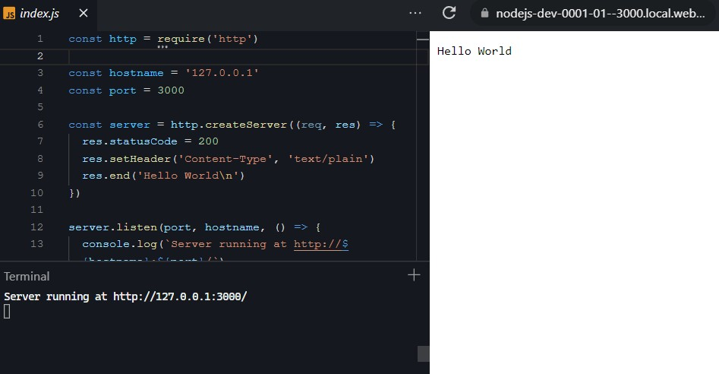

## How to Install Node.js

Node.js can be installed in different ways. This post highlights the most common and convenient ones.

Official packages for all the major platforms are available at <https://nodejs.dev/download/>.

One very convenient way to install Node.js is through a package manager. In this case, every operating system has its own.

Other package managers for MacOS, Linux, and Windows are listed in <https://nodejs.dev/download/package-manager/>

nvm is a popular way to run Node.js. It allows you to easily switch the Node.js version, and install new versions to try and easily rollback if something breaks, for example.

It is also very useful to test your code with old Node.js versions.

See <https://github.com/nvm-sh/nvm>for more information about this option.

In any case, when Node.js is installed, you'll have access to the node executable program in the command line.

## MongoDb

MongoDB is a NoSQL database which stores the data in form of key- value pairs. It is an **Open Source**, **Document Database** which provides high performance and scalability along with data modelling and data management of huge sets of data in an enterprise application.

MongoDB also provides the feature of Auto-Scaling. Since, MongoDB is a cross platform database and can be installed across different platforms like Windows, Linux etc.

MongoDB was developed by **Eliot Horowitz** and **Dwight Merriman** in the year **2007**, when they experienced some scalability issues with the relational database while developing enterprise web applications at their company **DoubleClick**.

### Features of MongoDb

* MongoDB provides high performance. Input/Output operations are lesser than relational databases due to support of embedded documents(data models) and Select queries are also faster as Indexes in MongoDB supports faster queries.
* MongoDB has a rich Query Language, supporting all the major CRUD operations. The Query Language also provides good Text Search and Aggregation features.
* Auto Replication feature of MongoDB leads to High Availability. It provides an automatic failover mechanism, as data is restored through backup(replica) copy if server fails.
* Sharding is a major feature of MongoDB. Horizontal Scalability is possible due to sharding.
* MongoDB supports multiple Storage Engines.

## Robo 3T

Robo 3T, formerly known as Robomongo is a popular resource for MongoDB hosting deployments. It provides a Graphical User Interface (GUI) to interact with bricks of data through visual indicators rather than text based interface. It is free and lightweight. We can call it a management tool for MongoDB that is shell-centric and cross-platform. It is not supported by JSON. It is highly specific to be used with MongoDB administrative tools for carrying out GUI based tasks. Moreover, its shell cannot be embedded into Mongo Shell being given access to the CLI and GUI in MongoDB.

It is a free machine-friendly software build to make use of the small number of resources available on a machine. It is a highly curated and recommended tool for various large-scale projects that need a high success ratio for generating prime output.

As a user we can easily overcome the problem of dealing with messy procedures of using tables and rows typically used in rational databases.

### Install Robo 3T

Visit website and install from there: https://robomongo.org/

## DART Programming Language

Dart is a client-optimized language for developing fast apps on any platform. Its goal is to offer the most productive programming language for multi-platform development, paired with a flexible execution runtime platform for app frameworks.

Languages are defined by their technical envelope- the choices made during development that shape the capabilities and strengths of a language. Dart is designed for a technical envelope that is particularly suited to client development, prioritizing both development (sub- second stateful hot reload) and high-quality production experiences across a wide variety of compilation targets (web, mobile, and desktop).

Dart has [a rich set of core libraries](https://dart.dev/guides/libraries), providing essentials for many everyday programming tasks:

* + Built-in types, collections, and other core functionality for every Dart program (dart:core)
  + Richer collection types such as queues, linked lists, hashmaps, and binary trees (dart:collection)
  + Encoders and decoders for converting between different data representations, including JSON and UTF-8 (dart:convert)
  + Mathematical constants and functions, and random number generation (dart:math)
  + File, socket, HTTP, and other I/O support for non-web applications (dart:io)
  + Support for asynchronous programming, with classes such as Future and Stream (dart:async)
  + Lists that efficiently handle fixed-sized data (for example, unsigned 8-byte integers) and SIMD numeric types (dart:typed_data)
  + Foreign function interfaces for interoperability with other code that presents a C-style interface (dart:ffi)
  + Concurrent programming using *isolates* — independent workers that are similar to threads but don’t share memory, communicating only through messages (dart:isolate)
  + HTML elements and other resources for web-based applications that need to interact with the browser and the Document Object Model (DOM) (dart:html).

Basic Dart Program

// Define a function.

void printInteger(int aNumber) {

print('The number is $aNumber.'); // Print to console.

}

// This is where the app starts executing. void main() {

var number = 42; // Declare and initialize a variable.

printInteger(number); // Call a function.

}

## Flutter

Flutter is an open source framework by Google for building beautiful, natively compiled, multi-platform applications from a single codebase.

Flutter will help you create beautiful, fast apps, with a productive, extensible and open development model.

### Beautiful user experiences

It enables designers to deliver their full creative vision without being forced to water it down due to limitations of the underlying framework. Flutter's layered architecture gives you control over every pixel on the screen and its powerful compositing capabilities let you overlay and animate graphics, video, text, and controls without limitation. Flutter includes a full set of widgets that deliver pixel- perfect experiences on both iOS and Android.

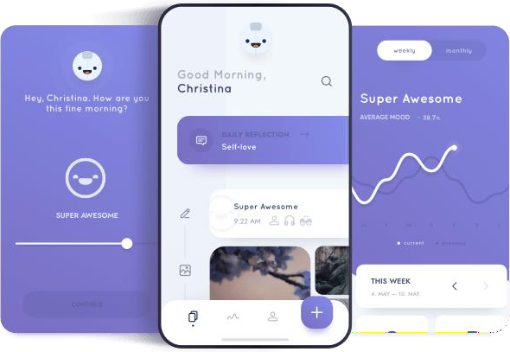

### Fast Results

Flutter is fast. It's powered by the same hardware-accelerated 2D graphics library that underpins Chrome and Android: Skia. We architected Flutter to support glitch-free, jank-free graphics at the native speed of your device. Flutter code is powered by the world- class Dart platform, which enables compilation to 32-bit and 64-bit ARM machine code for iOS and Android, as well as JavaScript for the web and Intel x64 for desktop devices.

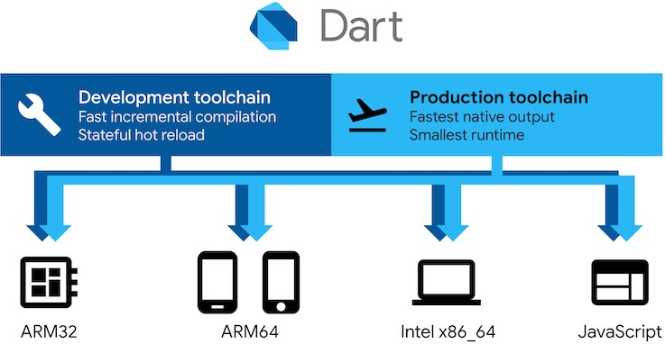

### Productive Development

Flutter offers stateful hot reload, allowing you to make changes to your code and see the results instantly without restarting your app or losing its state.

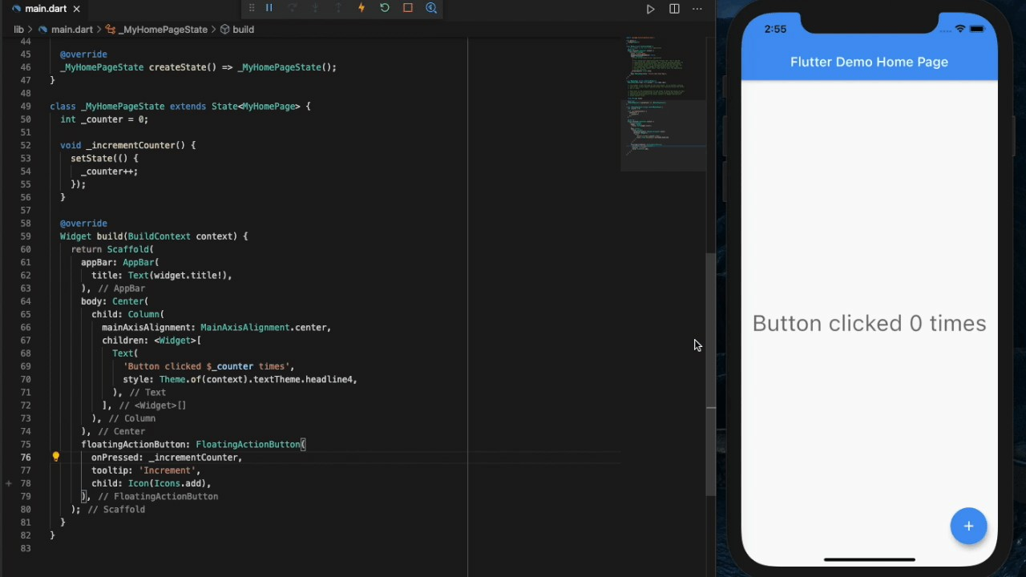

### Extensible and Open Model

Flutter works with any development tool (or none at all) but includes editor plug-ins for both Visual Studio Code and IntelliJ / Android Studio. Flutter provides thousands of packages to speed your development, regardless of your target platform. And accessing other native code is easy, with support for both FFI and platform-specific APIs.

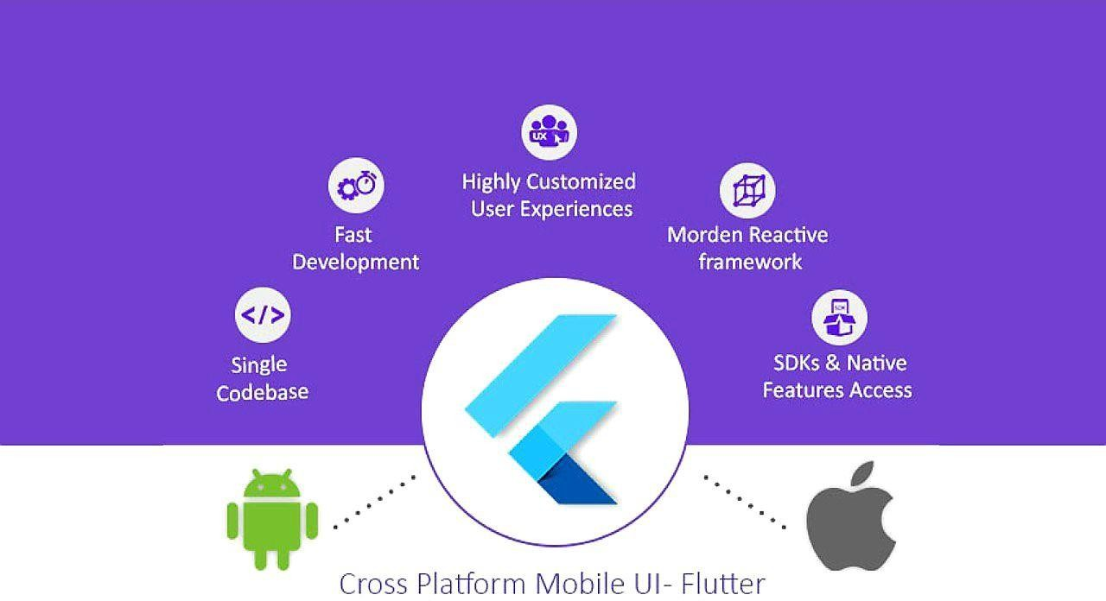

## Firebase

Firebase is a Backend-as-a-Service (BaaS) app development platform that provides hosted backend services such as a real-time database, cloud storage, authentication, crash reporting, machine learning, remote configuration, and hosting for your static files.

### Firebase for Flutter

Before any Firebase services can be used, you must first install the firebase_core plugin, which is responsible for connecting your application to Firebase.

Install the plugin by running the following command from the project root:



To initialize FlutterFire, call the [initializeApp](https://pub.dev/documentation/firebase_core/latest/firebase_core/Firebase/initializeApp.html) method on

the [Firebase](https://pub.dev/documentation/firebase_core/latest/firebase_core/Firebase-class.html) class. The method accepts your Firebase project application configuration, which can be obtained for all supported platforms by using the FlutterFire CLI:

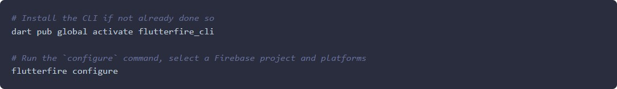

Next the generated options need to be provided to

the [initializeApp](https://pub.dev/documentation/firebase_core/latest/firebase_core/Firebase/initializeApp.html) method. Since this is an asynchronous operation, the main function can be modified to ensure initialization is complete before running the application.

First import the firebase_core plugin and generated firebase_options.dart file:

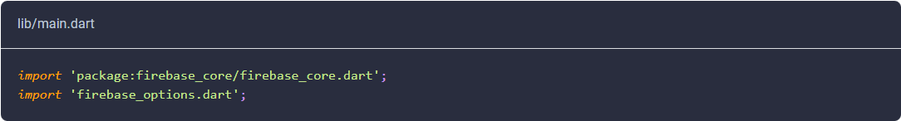

Next, within the main function, ensure WidgetsFlutterBinding is initialized and then initialize Firebase:

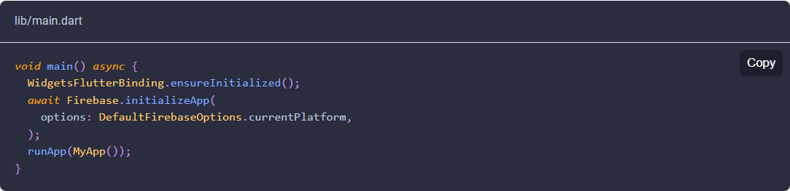

The DefaultFirebaseOptions.currentPlatform are imported from our generated firebase_options.dart file.

## Testing and Implementation

TESTING

Testing is the process of exercising software with the intent of finding errors and ultimately correcting them. The following testing techniques have been used to make this project free of errors.

### Content Review

The whole content of the project has been reviewed thoroughly to uncover typographical errors, grammatical error and ambiguous sentences.

### Navigation Errors

Different users were allowed to navigate through the project to uncover the navigation errors. The views of the user regarding the navigation flexibility and user friendliness were taken into account and implemented in the project.

### Unit Testing

Focuses on individual software units, groups of related units.

* Unit – smallest testable piece of software.
* A unit can be compiled /assembled / linked/loaded; and put under a test harness.
* Unit testing done to show that the unit does not satisfy the application and /or its implemented software does not match the intended designed structure.

### Integration Testing

Focuses on combining units to evaluate the interaction among them

* Integration is the process of aggregating components to create larger components.
* Integration testing done to show that even though components were individually satisfactory, the combination is incorrect and inconsistent.

### System testing

Focuses on a complete integrated system to evaluate compliance with specified requirements (test characteristics that are only present when entire system is run)

* A system is a big component.
* System testing is aimed at revealing bugs that cannot be attributed to a component as such, to inconsistencies between components or planned interactions between components.
* Concern: issues, behaviours that can only be exposed by testing the entire integrated system (e.g., performance, security, recovery)each form encapsulates (labels, texts, grid etc.). Hence in case of project in

V.B. form are the basic units. Each form is tested thoroughly in term of calculation, display etc.

### Regression Testing

Each time a new form is added to the project the whole project is tested thoroughly to rectify any side effects. That might have occurred due to the addition of the new form. Thus regression testing has been performed.

### White-Box testing

White-box testing (also known as clear box testing, glass box testing, transparent box testing and structural testing) tests internal structures or workings of a program, as opposed to the functionality exposed to the end-user. In white-box testing an internal perspective of the

system, as well as programming skills, are used to design test cases. The tester chooses inputs to exercise paths through the code and determine the appropriate outputs. This is analogous to testing nodes in a circuit, e.g. in-circuit testing (ICT).

While white-box testing can be applied at the unit, integration and system levels of the software testing process, it is usually done at the unit level. It can test paths within a unit, paths between units during integration, and between subsystems during a system–level test.

Though this method of test design can uncover many errors or problems, it might not detect unimplemented parts of the specification or missing requirements.

Techniques used in white-box testing include:

API testing (application programming interface) – testing of the application using public and private APIs.

Code coverage – creating tests to satisfy some criteria of code coverage (e.g., the test designer can create tests to cause all statements in the program to be executed at least once).

Fault injection methods – intentionally introducing faults to gauge the efficacy of testing strategies.

Code coverage tools can evaluate the completeness of a test suite that was created with any method, including black-box testing. This allows the software team to examine parts of a system that are rarely tested and ensures that the most important function points have been tested. Code coverage as a software metric can be reported as a percentage for:

Function coverage, which reports on functions executed Statement coverage, which reports on the number of lines executed to complete the test 100% statement coverage ensures that all code paths, or branches (in terms of control flow) are executed at least once. This is

helpful in ensuring correct functionality, but not sufficient since the same code may process different inputs correctly or incorrectly.

### Black-box testing

Black-box testing treats the software as a "black box", examining functionality without any knowledge of internal implementation. The tester is only aware of what the software is supposed to do, not how it does it. Black-box testing methods include: equivalence partitioning, boundary value analysis, all-pairs testing, state transition tables, decision table testing, fuzz testing, model-based testing, use case testing, exploratory testing and specification-based testing.

Specification-based testing aims to test the functionality of software according to the applicable requirements. This level of testing usually requires thorough test cases to be provided to the tester, who then can simply verify that for a given input, the output value (or behaviour), either "is" or "is not" the same as the expected value specified in the test case. Test cases are built around specifications and requirements, i.e., what the application is supposed to do. It uses external descriptions of the software, including specifications, requirements, and designs to derive test cases. These tests can be functional or non- functional, though usually functional.

Specification-based testing may be necessary to assure correct functionality, but it is insufficient to guard against complex or high- risk situations.

One advantage of the black box technique is that no programming knowledge is required. Whatever biases the programmers may have had, the tester likely has a different set and may emphasize different areas of functionality. On the other hand, black-box testing has been said to be "like a walk in a dark labyrinth without a flashlight." Because they do not examine the source code, there are situations when a tester writes many test cases to check something that could

have been tested by only one test case, or leaves some parts of the program untested.

This method of test can be applied to all levels of software testing: unit, integration, system and acceptance. It typically comprises most if not all testing at higher levels, but can also dominate unit testing as well.

### Alpha Testing

Alpha testing is simulated or actual operational testing by potential users/customers or an independent test team at the developers' site. Alpha testing is often employed for off-the-shelf software as a form of internal acceptance testing, before the software goes to beta testing.

### Beta Testing

Beta testing comes after alpha testing and can be considered a form of external user acceptance testing. Versions of the software, known as beta versions, are released to a limited audience outside of the programming team. The software is released to groups of people so that further testing can ensure the product has few faults or bugs.

Sometimes, beta versions are made available to the open public to increase the feedback field to a maximal number of future users.

## Implementation

### Web Portal of Dhirati Education Login Page

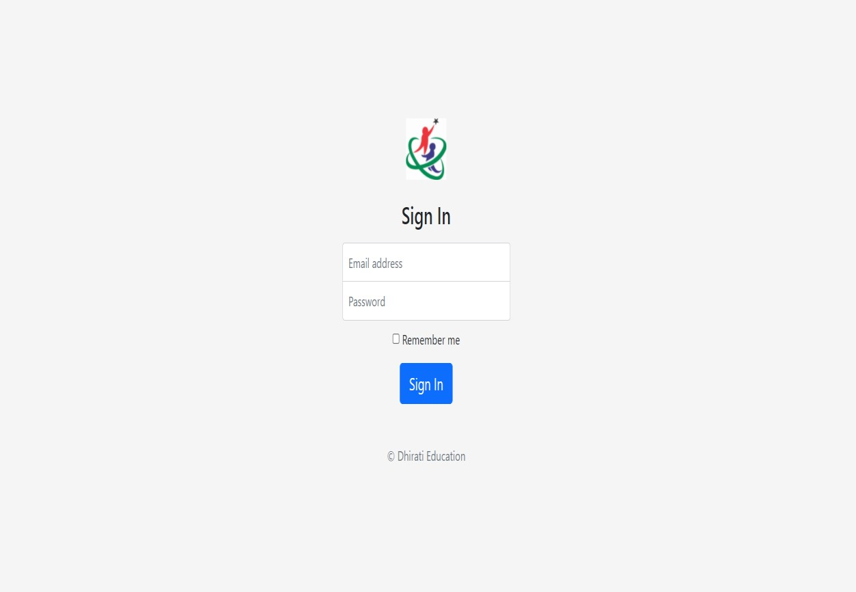

**Popup Page**

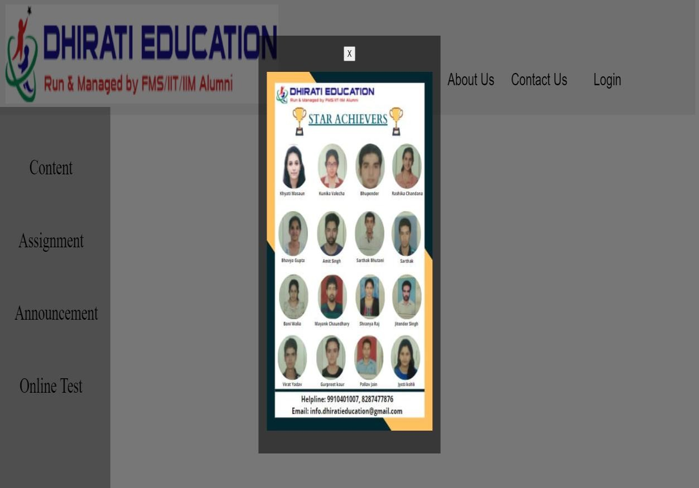

### Web Page

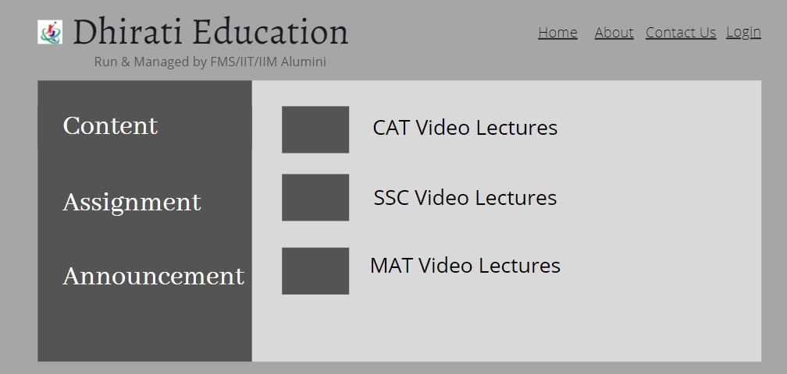

**Hover Effects On Web Page**

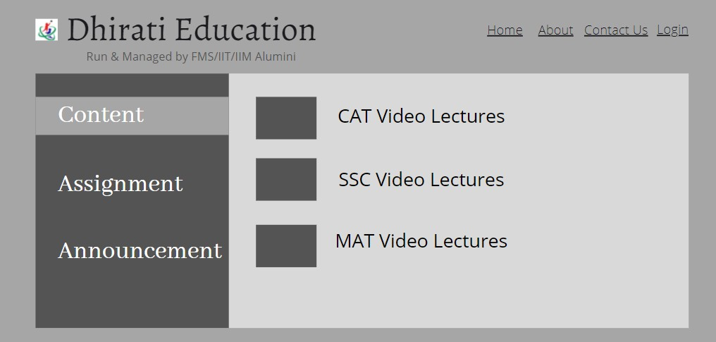

### Hover Effect In Header

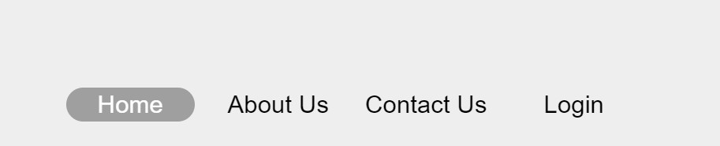

**App of Dhirati Education Splash Screen**

Splash Screen is created for Dhirati Education App with little animation. It is created using flutter package splash screen.

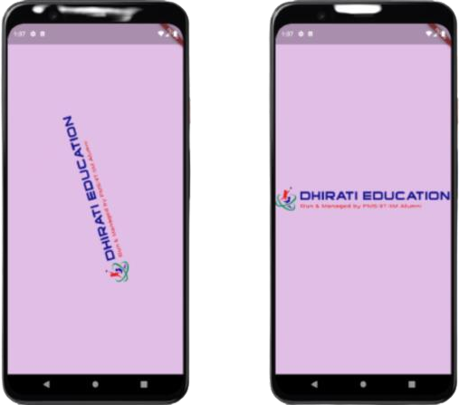

### Introdction Screen

It basically gives you information about Dhirati Education and their features.

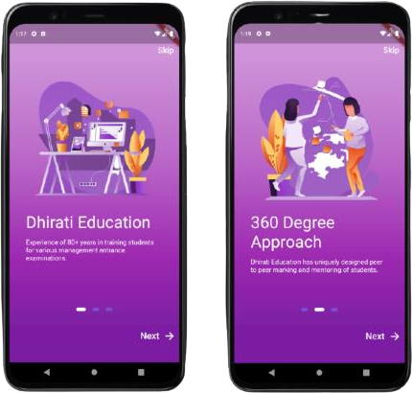

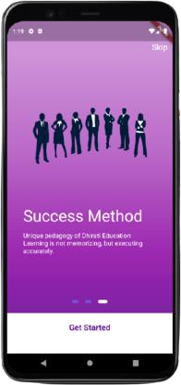

### Navigation Bar

It is created at the bottom of the screen. It is made for best user experience.



### Dashboard

It is created to list all the important information of dhirati education. Because after introduction screen, Dashboard open up, so for getting more info about this app is listed here and the popular courses are

also added here you can swipe left and right to see it and select by clicking on it.

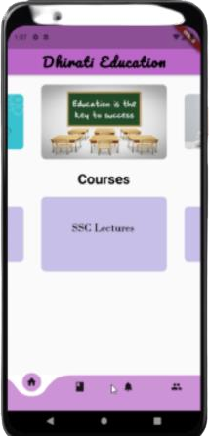

### Course Section

It is designed in tile forms all the courses are listed in courses section. We can also swipe up and swipe down to see more courses and select according to your interest.

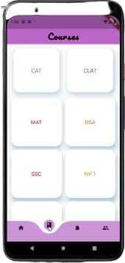

### Sub Course Section

It opens the course you selected and here you can find videos and notes of that particular subject. You can also see previous year question paper. All the remaining things are added soon in this section.

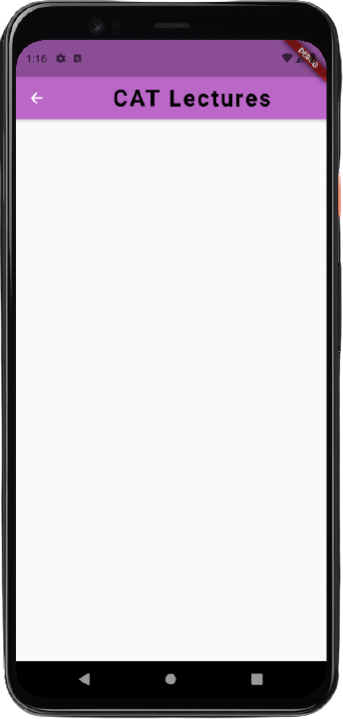

### Announcement Section

In this section admin can add the important announcements related to your course or related to your upcoming tests.

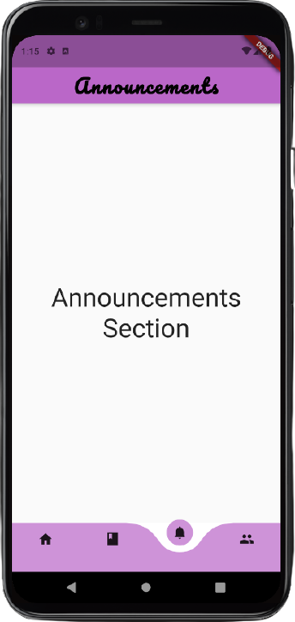

### Contact Section

It contains contact information of Dhirati Education. If users have any queries or wanted to ask something then they refer to this section and contact Dhirati Education for further queries.

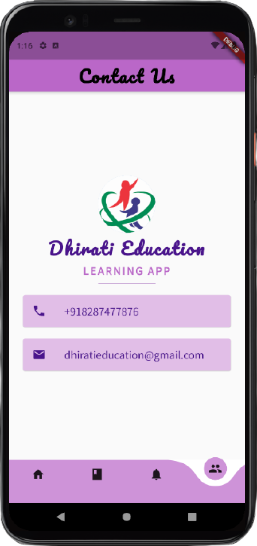

## Learning’s and Value Addition

An internship is a learning experience of its own kind. Neither is it spoon-fed school learning, nor pressure filled workload. It is in between and in between; I not only learn the basics of work life but also the skills required for a brighter professional career.

During my internship I had learned lots of thing and few of them I’m mentioning here:

Teamwork: It is important because it enables your team to share ideas and responsibilities, which helps reduce stress on everyone, allowing them to be meticulous and thorough when completing tasks.

Problem Solving Skills: It allow you to find candidates who are cognitively equipped to handle anything their jobs throw at them. Problem solvers can observe, judge, and act quickly when difficulties arise when they inevitably do.

Work Ethics: Workplace ethics ensures positive ambience at the workplace. Workplace ethics leads to happy and satisfied employees who enjoy coming to work rather than treating it as a mere source of burden.

Adaptability Skills: It expands your capacity to handle change, no matter how serious it might be. Instead of throwing away your energy trying to change your circumstance, you will change yourself right from within, thus making you thrive in whatever situation you find yourself.

Communication Skills: It is fundamental to the existence and survival of humans as well as to an organization. It is a process of creating and sharing ideas, information, views, facts, feelings, etc. among the people to reach a common understanding.

Responsibility: Each step we take towards being responsible and productive helps to raise our self-esteem and our relationships with friends, family and co-workers improve ten-fold.

Time Management: It helps you prioritize your tasks so that you ensure you have enough time available to complete every project. The quality of your work increases when you're not rushing to complete it ahead of a fast approaching deadline.

## Theoretical v/s Practical Knowledge

Practical knowledge is knowledge that is acquired by day-to-day hands-on experiences. In other words, practical knowledge is gained through doing things; it is very much based on real-life endeavors and tasks. On the other hand, theoretical knowledge teaches the reasoning, techniques and theory of knowledge. While practical knowledge is gained by doing things, theoretical knowledge is gained, for example, by reading a manual.

Practical knowledge and theoretical knowledge are two completely distinct approaches to knowledge. While theoretical knowledge may guarantee that you understand the fundamental concepts and have know-how about how something works and its mechanism, it will only get you so far, as, without practice, one is not able to perform the activity as well as he could. Practical knowledge guarantees that you

are able to actually do something instead of simply knowing how to do it.

During this internship, I had only theoretical knowledge about some programming language never build any thing before. But during this internship mentor assigned me a task for web portal and then I try to make that first I made mockup and yes it is my first mock up I had made ever. Then some research is important to work practically on a project. So, I did that and share that with Saurav and get some review. He told me some of my mistakes and then I correct them accordingly because app is used by many people, so some feedback is really important, and I really get some positive feedback as well as some negative from him and all that are honest. So, on the negative feedback, I research again for that and end up with good user experience. By doing this I got lots of practical knowledge with theoretical knowledge.

Theoretical and practical knowledge are interconnected and complement each other — if one knows exactly HOW to do something, one must be able to apply these skills and therefore succeed in practical knowledge.

## CONCLUSION

The project “Web Portal of Dhirati Education” aims to simplify getting the notes and video lectures using correct username and password.

Enter username and password issued by Dhirati Education. It only allow user to view the content if username and password matches correctly. Authentication is secure during the process.

The project “App of Dhirati Education” aims to get information about Dhirati Education. This app had good user experience and amazing content for any exam preparation. You can also check popular courses on the dashboard and keep track of important announcement in an individual section. Also if you have any more doubts about Dhirati Education you can refer to contact section.

REFERENCES

[1] Kapp, K.M. 2012. The gamification of learning and instruction: game-based methods and strategies for training and education, John Wiley & Sons, Hoboken, NJ, USA.

[2] Ge, X. and Ifenthaler, D. 2018. Designing engaging educational games and assessing engagement in game-based learning” In Gamification in Education: Breakthroughs in Research and Practice, 1-19, IGI Global, Hershey, USA.

[3] Hwang, G.J. and Wu, P.H. 2012. Advancements and trends in digital game‐ based learning research: a review of publications in selected journals from 2001 to 2010,” Brit. J. of Educ. Tech. 43(1), E6- E10.

[4] Kinzie, M.B. and Joseph, D.R. 2008. Gender differences in game activity preferences of middle school children: implications for educational game design, Educ. Tech. Res. and Dev. 56(5-6), 643- 663.

[5] Carvalho, M.B., Bellotti, F., Berta, R., De Gloria, A., Sedano, C.I., Hauge, H.B., Hu, J. and Rauterberg, M. 2015. An activity theory-based model for serious games analysis and conceptual design,” Computers & Education. 87, 166-181.

[6] Connolly, T.M., Boyle, E.A., MacArthur, E. Hainey, T. and Boyle, J.M. 2012. A systematic literature review of empirical evidence on computer games and serious games,” Comp. & Educ. 59(2), 661-686.

[7] Crookall, D. 2010. Serious games, debriefing, and simulation/gaming as a discipline, Sim. & Gaming. 41(6), 898-920.

[8] Sandholtz, J.H. 1997. Teaching with technology: Creating student-centered classrooms. Teachers College Press, New York, USA.

[9] Lugmayr, A., Sutinen, E., Suhonen, J., Sedano, C.I., Hlavacs, H., and Montero, C.S. 2017. Serious storytelling–a first definition and review, Multimedia Tools and Applic.. 76(14), 15707-15733.

[10] Wouters, P. Van Nimwegen, C. Van Oostendorp, H. and Van Der Spek, E.D. 2013. A meta-analysis of the cognitive and motivational effects of serious games, J. of Educ. Psych. 105(2), 249-266.

## Bibliography

* Install Robo3T: <https://robomongo.org/download>
* For learning Dart Programming Language: <https://dart.dev/tutorials> <https://dart.dev/guides> <https://medium.com/dartlang>
* For learning Flutter: <https://docs.flutter.dev/> <https://docs.flutter.dev/reference/tutorials> <https://github.com/flutter/flutter>
* Flutter Packages: <https://api.flutter.dev/flutter/material/material-library.html> <https://api.flutter.dev/flutter/material/Scaffold-class.html>
* Install Flutter: <https://docs.flutter.dev/get-started/install>
* Installed Flutter Packages: <https://pub.dev/>

<https://pub.dev/packages/curved_navigation_bar> <https://pub.dev/packages/animated_splash_screen> <https://pub.dev/packages/flutter_staggered_grid_view> <https://pub.dev/packages/carousel_slider>

* Firebase: <https://firebase.google.com/> <https://firebase.google.com/docs>